**Please edit all generic text in red. Read in entirety and re-appropriate for your specific school’s situation**

JOHNSON SCHOOL DISTRICT EDUCATION COMMUNITY

Grant Application Form

Date: ____________________

_________________________ _________________________
Applicant’s Name School Phone

_________________________ _________________________
Position Building/School

_________________________ _________________________
Project Title Budget Request

1. Describe your project. (Include materials you will need and methods you'll use)

This project is being requested to provide necessary innovation to the the current strength and conditioning program and the physical education department at Johnson High School. This project is an effort to improve overall health and athletic performance of Johnson High School students as well as make needed technology-based improvements to the efficiency and productivity of the weight room at Johnson High School. The materials being requested for this project are a software subscription to the TeamBuildr Platinum plan, 10 tablets with wireless internet connection and 10 magnetized tablet mounts. These tablets and tablet mounts would be compatible to run an online strength and conditioning software system called TeamBuildr (https://teambuildr.com/). Through discussions and video conferencing with representatives from TeamBuildr, they supplied us with an initial quote for the technology being requested (attached at the bottom).

TeamBuildr is a cloud-based strength training software that allows for advanced customization and differentiation on an individual basis. This system will be used universally across the HS physical education department, Johnson High School athletics, and Johnson High School strength and conditioning program. TeamBuildr is a program that is equally effective for a general student in a PE class as it is for a top-tier athlete improving overall athletic performance. The TeamBuildr platform and the workouts created by coaches/teachers are accessible anywhere at any time. This system will provide hundreds of data points for coaches to review on a daily basis for every one of their athletes to assess their current needs. Coaches/teachers have access through their administrator account to all of their athletes/students to best identify those specific needs in students.

The TeamBuildr software runs on any smart device with an internet connection. Each student will have their own account within TeamBuildr where their weight data is stored and where individual workouts tailored specifically to that student-athlete are completed. This information is viewable and customizable on the back end by the coach/teacher to assess how the student performed and make any modifications necessary for continued improvement. Once the daily workout is completed, all of the data related to the workout (exercises completed, sets/reps completed, weight, etc.) is saved to the cloud and stored for as long as the athlete is in the system.

With the tablets being requested, students will have constant access to their workouts while they are completing them in real-time. The tablet rack mounts are magnetized, which allows them to be placed securely on the weight training racks in the weight room. These tablet mounts hold the tablets and allow students to access their workout while completing it. An example of what the tablet/rack mount setup will look like has been included (images at the bottom). With the expansion of the weight room planned in the next couple of years, we will have 10 total weight training racks. The 10 tablets and 10 rack mounts represent one tablet/mount per rack.

A specific feature of the TeamBuildr system is called “Weight Room View” which will be utilized extensively. Weight Room View allows up to 4 athletes to be signed into their individual accounts on the same tablet simultaneously (images at bottom). Because 3-4 people generally share a weight rack due to space needs, this will greatly improve the ability of coaches to manage all athletes to ensure the complete and successful workout is completed. This innovation will maximize efficiency in training program completion and ensure that all students/athletes are performing at their highest level physically and athletically .

The program allows workouts and specific exercises to be completed far more efficiently than other methods. By improving the efficiency by which workout plans are created, it further allows coaches and physical education teachers to differentiate for students and athletes alike. This technology gives back the coach’s ability to coach rather than spend time figuring out various workout plans and what each athlete should be doing. Because it is cloud-based, all workouts and specific exercises are saved and stored within the system to be accessed easily at a later time. This gives coaches and teachers the ability to modify workouts based on data from the past.

2. What is the main problem this project addresses? Why do you think there is a special need for this project?

It is vital that we use our updated facilities in the best way possible to help our students succeed. Specific to this request, the expansion of the weight room and the many modifications that come with it is very important to the competitive success of our athletes and the overall health of our PE students. If we hold back improvement of our athletics department to the facilities alone, in my mind we are not making any lasting changes. For athletic and performance-based improvement to fully occur, we need to change the methods and programs that are in use at our great facilities. For this reason, TeamBuildr is necessary to bring our athletics, physical education, and strength and conditioning programs to the forefront of athletic advancement.

With the advancements of the weight room and other athletic facilities, the improvement of the education around strength and conditioning is also becoming innovative. Our PE class is an advanced opportunity for students, athletes or non-athletes, to participate in a strength and conditioning program and be exposed to lifelong exercise skills. This class gives students the choice to fit their schedule to their specific interests in terms of physical activity. When students are given choices in terms of the types of classes they participate in, their motivation to succeed and improve their physical fitness increases. By using the TeamBuildr platform in this class, students will be further motivated to participate in physical activity outside of the school environment by viewing their individual data on a daily basis and setting goals that are specific to their own performance. Also, TeamBuildr will be necessary in the years to come with the anticipated addition of the option for students to take strength and conditioning classes built into the regular school schedule. With the improvements in facilities and space, there are numerous possibilities for the various options students have in regard to their physical education interests.

Using the tablets with the TeamBuildr platform will eliminate the usage of paper in the weight room and maximize organization. With hundreds of athletes participating in athletics at Johnson High School and additional students that are on strength and conditioning programs, there is a large amount of paper used on a weekly basis. Furthermore, this abundance of paper workout sheets creates a huge organizational problem. Currently a jam-packed filing cabinet is used to sort individual student workouts. With such a high number of multi-sport athletes, it is very difficult to organize students based on the sport they play season to season. This becomes difficult for coaches to know what workouts athletes have and have not completed, where they are at in their current program, and where they are at athletically. This creates a gap of understanding between a coach and his/her athletes which can be lead to improperly-informed discussions about the specific needs of individual athletes. Additionally, the TeamBuildr platform is mobile and can be accessed anywhere, making it possible for students to complete workouts on their own if desired by the coach/teacher.

Because the workouts are created and united under one platform, it creates the necessity of our various sports teams to work together in order to give student-athletes the skills they need to be successful. This advanced communication will help bolster our athletic department to be more synced and more competitive as a result. Also, the data collected by using the system provides coaches and teachers with daily feedback that has never been accessible in the past. These various data points are compiled on a daily basis, allowing coaches to see trends and the change in performance of athletes. More so, this accessibility to statistical representation of what athletes are achieving will become a vital motivational tool for coaches and athletes alike. When students have the ability to physically see trends in their performance and more easily track performance indicators (weight lifted, maximal weight lifted, body composition, etc.) intrinsic motivation comes into play as well as the motivation provided by coaches and teachers. This additional tool for motivating student- athletes will create “buy-in” to our programs and help instill a positive culture in our strength and conditioning program as a whole.

3. Give a time schedule of events.

Upon receiving approval for this project, the tablets and rack mounts will be ordered. Once the tablets and rack mounts are received, the athletic director and other coaches involved in the strength and conditioning/athletics program will sit down and work through a free 2-week trial of the TeamBuildr software. During this trial, we will be creating all accounts for students in academic classes as well as athletic teams, creating a vast database of exercises, differentiating workouts, etc. in order to get a majority of the laborious work done ahead of time. The trial will be used to test the tablets and rack mounts alongside the software with students during the summer lifting program. Once this 2-week trial ends, our accounts and all of our data entered will be saved until we actually purchase the software.

Once the TeamBuildr software is actually purchased, all of our work from the 2-week trial will be carried over. This will give us the opportunity to work through any setbacks that may occur during the 2-week trial. The TeamBuildr software is a 1-year subscription and would be purchased again every year following for $1,000 per year. TeamBuildr also offers multi-year contracts which will apply discounts to their recurring subscription prices.

4. Approximately how many pupils will be affected by this project?

All students in the high school building have the opportunity to benefit from having the tablets and rack mounts to run the TeamBuildr software. With the integration into athletics, physical education, and the strength and conditioning programs, every student who takes physical education class and/or the early bird strength and conditioning class will have the opportunity to work with this technology. Additionally, every student-athlete at Johnson High School will use the tablets and rack mounts with the TeamBuildr platform. With that being said, every student at Johnson High School would have the opportunity to interact with this software and improve their physical fitness/athletic performance.

5. Detail your budget request. Include specific information such as kinds of materials and equipment needed, source(s) of supplies and costs, and matching funds that will be provided.

The specific tablets that are being requested are Apple iPad (latest generation). These tablets are very durable and fit into the rack-mount well. From the representatives at TeamBuildr, these are one of the best tablets they recommend for running the TeamBuildr software. These tablets will be functional for years and will work exceptionally well for the software that will be run on them. The sole purpose of these tablets will be to run the TeamBuildr software, so no additional storage is necessary with the cloud- based technology. TeamBuildr has these tablets currently listed at $350.00 each.

The specific rack mounts that will be purchased are through a company called MobArmor that has a partnership with TeamBuildr. These rack mounts secure and protect the iPads entirely which eliminates the needs to purchase tablet cases.. They are extremely durable and come with a 1-year warranty. The specific model we will be purchasing is called the MobArmor T3. TeamBuildr and the MobAmor website price these rack mounts at $200.00 per mount.

The estimate that has been attached at the bottom is representative of the overall funds being requested ($6,500.00) and the individual cost of the technology. This technology will positively impact the lives of all students at Johnson High School and help create healthier generations to come.

________________________ _____________________________
Applicant's Signature Signature of Building Principal or Supervisor

Forward this proposal to your building principal.
If you have questions or need assistance, call the Superintendent of Schools.

Please product photos or images here.

Please attach product or service estimate (total estimate for product subscription and all hardware):
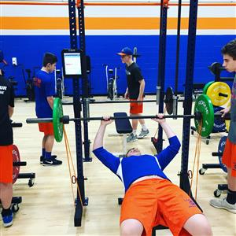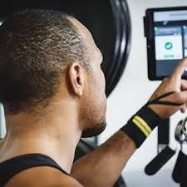
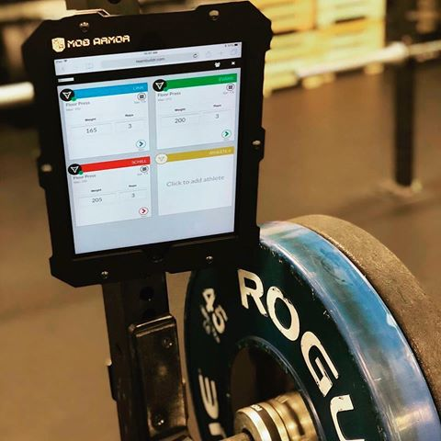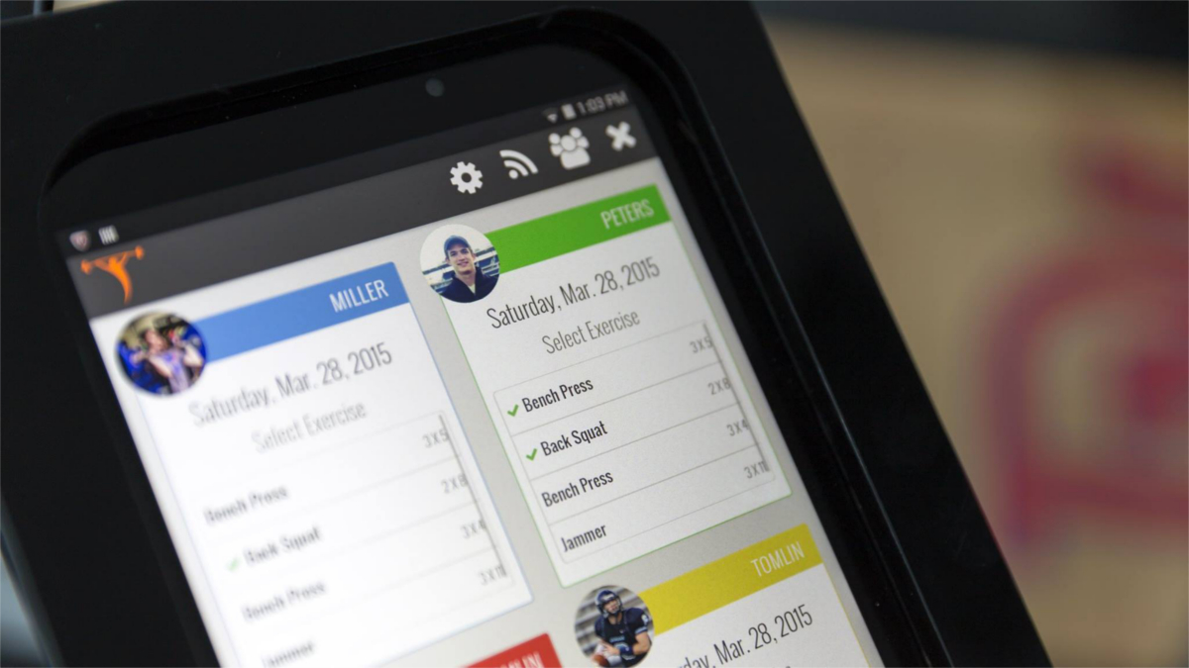

**(This is a sample estimate. You can request an estimate from TeamBuildr directly)**
